# Task:

**Task**

You have been tasked with creating a **showcase of your learning**. Your showcase will use the focus on a **Tool of Learning**: the creation of a software solution to play and solve wordle. The default showcase will be an **A2 poster** of your learning and **one recorded presentation** for a general audiences.

# Tool of learning

Wordle is a game played by millions of players. It is a guessing game where punters guess entire words and are given clues. The rules of wordle are simple:

* You must guess the word in six goes or less
* Every word you enter must be in the word 10,000-word list.
* A correct letter turns green
* A correct letter in the wrong place turns yellow
* An incorrect letter turns grey
* Letters can be used more than once
* Answers are never plurals
* Players can prove how clever they are by sharing their results without giving away the answer.

# Tasks for learning and submissions

### Core learning task

* Create a program that simulates the selection and display of words
* Extend that program to make informed guesses to win.

The default expectation is:

* The solution will be on the command line
* The game uses its own word list and selects a word by random
* The game gives appropriate clue like the real client using the Rich client or other modules
* The game follows the rules above
* The application runs from the command line using argparse, and allows for the following options:   
  Text

  Description automatically generated

### Submissions

* A planning document that identifies the steps you need to complete to solve the problem.
* A runnable program
* A video of the game being played and solved programmatically autonomously at least 10 times in sequence without breaks or editing.
* A poster presentation of your learning. This poster responds to 3 reflective statements (see below) and is designed for general audiences.
* A presentation that includes your poster and video which is designed for general audiences
* A presentation that includes your poster/video which is designed for technical audiences.

# Showcase Responses

Your **poster and presentation must respond to three statements** and present different levels of information to describe what it is you learnt and how that knowledge can be used in cyber security.

The statements will be provided in the rubric below. You must address your responses to the three audiences:

1. Poster – **summarise your learning for general audiences** in a condensed writing environment
2. General audience presentation – simulates presenting your work and learning to a **general audience and allows for some extrapolation**

Your general audience presentation should no longer than **5 minutes**

##### Section 1: Knowledge Comprehension, and Application

This section of the rubric consists of the required elements of the assignment. Students should take special care to include ALL these elements as they are often extended in the following sections

##### Section 2: Analysis, Synthesis, and Evaluation.

This section will evaluate your ability to include critical thinking and justification elements into your work. Often the requirements for extension are not explicitly given, so it will be up to the you to decide how best to demonstrate what you have learned beyond the required unit goals and curriculum. Items such as 3D models, pictures, drawings, diagrammatic responses, notes, evidence of problem solving, advanced programming concepts, elegant responses, media, etc., are all available options.

##### Section 3: Submission Guidelines

For this section, students will be expected to provide a submission which fulfills all of the formatting and citation requirements listed in this assessment sheet but also that the submission is of a professional quality. Be aware, points in this section could be 2- or 4-point items. Treat them accordingly.

## Submission

All submission items should be stored in an appropriate format. For example, code must be stored in a programmatical format so it can be evaluated (**images of code, or code simply copied and pasted into a document, will not be marked**)

Evidence of working material must be recorded where appropriate. For example, if you are showing how your game meets some requirement, you must submit a recording. Similarly, if you are showing how your robot meets a requirement, you must record it.

If you are unsure if an element needs to be recorded, **ask the teacher.**

**All materials must be submitted to google classrooms.**

Students are responsible for keeping backups/master-copies.

## SCORING NOTES

Formatting for all typed/written assessments should be as follows:

|  |  |  |  |  |  |  |
| --- | --- | --- | --- | --- | --- | --- |
| Google Doc | 11-12 Pt | 1.15-1.5 Line Spacing | 1 Space between paragraphs | Spelling and Grammar “Soft Limit” | In-Text Citations with footnotes | Title Page/Slide:   * Name * Date * Class * Aim * Assessment title |
| Slides | 10-12 pt. font text  14-24 pt. font titles | 1.0 1.15 Line Spacing | Bullet Points Preferred | Word Count per slide >100-110 “Soft Limit” | Approved Templates and Themes |
| Code |  |  |  |  |  |  |
| Markdown |  |  |  |  |  |  |

*“Soft Limits” are not rigidly defined limits and will be assessed on a case-by-case basis. Ask for clarification for specific tasks*

## Possible Scoring Groups are out of 2 or 4 Points.

**2-Point Criteria - Knowledge and Understanding**

*Criteria assessed as 2-Points are classified as Knowledge and Understanding criteria. These will examine and evaluate a student’s ability to state facts and define terms and concepts effectively. Analysis and synthesis of the information will not be assessed through these criteria.*

|  |  |  |  |
| --- | --- | --- | --- |
|  | **0 Points** | **1 Point** | **2 Points** |
| **2 Point Criteria** | Not present or able to be assessed as the required criteria | Item is presented and **does meet** expectations for quality, rigour, or detail | Item is presented and **does** meet expectations for quality, rigour, or detail |

**4-Point Criteria - Analysis and Synthesis and Expert Review**

*To show true mastery of your developing skills, students must show that they can go beyond simple repetition of the given tasks or an explanation of processes. Students will show their ability to show higher order thinking through analysis, evaluation, or the linking of multiple fields of learning to solve problems in novel ways.*

**Analysis and Synthesis**

*Analysis and Synthesis components evaluate a student’s ability to effectively review data and understandings and develop these into a coherent and relevant statement. Analysis refers to the generating of thoughts from interpreting the data, while synthesis refers to combining analysis of the data with other relevant information to develop an original and effective idea.*

|  |  |  |  |  |  |
| --- | --- | --- | --- | --- | --- |
|  | **0 Points** | **1 Point** | **2 Points** | **3 Points** | **4 Points** |
| **4 Point Criteria** | Not present or able to be assessed as the required criteria | Item is **presented and explained**. However, it **does not show any evidence of higher order thinking** such as analysis, evaluation, or synthesis. | Item is presented and **shows appropriate evidence of higher order thinking** such as analysis, evaluation, or synthesis. | Item is presented and **exceeds** **expectations** for **evidence of higher order thinking** such as analysis, evaluation, or synthesis.  **-or-**  Item is presented and **shows appropriate evidence of higher order thinking** such as analysis, evaluation, or synthesis and **exceeds expectations** for quality, rigour, or understanding of the selected mastery. | Item is presented and **exceeds** **expectations** for **evidence of higher order thinking** such as analysis, evaluation, or synthesis. Additionally, this item **exceeds expectations** for quality, rigour, or understanding of the selected mastery. |

**Expert Review**

*Expert Reviews evaluate a student’s ability to build solutions using the skills that have been taught during the semester. Criteria assessed as 4-Points are classified as Analysis and Synthesis criteria. These will examine and evaluate a student’s ability to effectively review data and understandings and develop these into a coherent and relevant statement. Analysis refers to the generating of thoughts from interpreting the data, while synthesis refers to combining analysis of the data with other relevant information to develop an original and effective idea.*

|  |  |  |  |  |  |
| --- | --- | --- | --- | --- | --- |
|  | **0 Points** | **1 Point** | **2 Points** | **3 Points** | **4 Points** |
| **4 Point Criteria** | Not present or able to be assessed as the required criteria | Item is **presented** and broadly **solves the problem**. However, upon review, it **does not** show any evidence of appropriate mastery. | Item is **presented** and broadly **solves the problem**. On review, it **does** show any evidence of appropriate mastery. | Item is **presented and solves the specific problem**. On review, the evidence shows understanding **beyond expected mastery**.  -or-  Item is **presented** and broadly **solves the problem**. On review, it **does** show any evidence of appropriate mastery and is done so in a **well-constructed** or design method that **clearly shows higher levels of understanding**. | Item is **presented and solves the specific problem**. On review, the evidence shows understanding **well** **beyond expected mastery** and is done so in a **well-constructed** or design method that **clearly shows higher levels of understanding**.. |

**Multiplier**

Criteria will be combined with a **Multiplier**. While each criterion will be scored on the 0-1-2-4 scale, the multiplier will attach relevant worth to each criterion. Be aware of these multipliers and dedicate appropriate time to ensure you achieve your best result.

**Achievement Standards:**

**Evidence of higher order learning:**

What is it that I mean by “higher order thinking”?

It means I want you to go beyond just replicating what we do in class. I want you to dig into your brain and understand why you did something, what about it was great, what could be improved.

Why is this important? Reflective thinkers are able to go beyond what they are taught and can customise their learning to ben

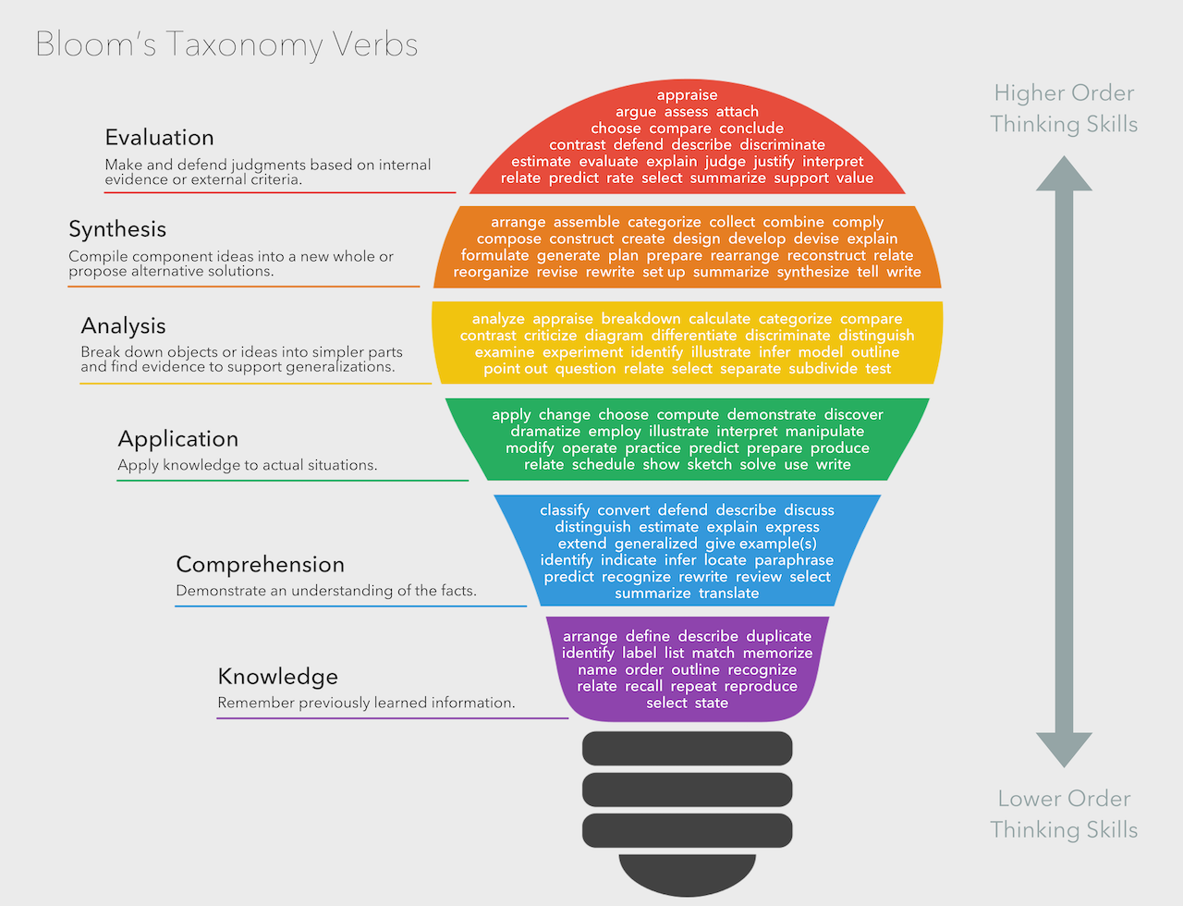

## Rubric

|  |  |  |  |  |  |  |
| --- | --- | --- | --- | --- | --- | --- |
|  | **Knowledge, Comprehension & Application** |  |  |  |  |  |
| **CRITERIA** | **EXPECTATIONS** | **POSS** | **STUDENT** | **GIVEN** | **MULTI** | **TOTAL** |
| **Wordle** | You have **submitted evidence of completing a program that hosts and plays wordle**.  Your evidence consists of **python files and videos of your program** **playing** in all required states.  Your submission seemingly appears to include the following features as a minimum:   * **Emulates the spirit of the wordle game** by using the majority of rules as defined above. * **Uses argparse** to allow a range of play modes, including auto_play, manual_play, and using bespoke word lists for both generations of games and auto_play * The game uses some enrichment **library (like Rich)** to provide additional context for guesses * The **game can play autonomously or manually**   Evidence for knowledge, comprehension, and application may include:   * **Knowledge**: Your evidence highlights that you recall and list relevant terms covered in your learning. It may tell a story to the reader (the teacher) or state your learning conditions. * **Comprehension**: Your evidence highlights that you can identify key aspects of your learning or explain what you've done to the author. * **Application**: It is clear from your evidence that you constructed a complete submission | 2  2  2  2 | __/2 __/2 __/2  __/2 | __/2 __/2 __/2  __/2 | A x2  T x 1 | A __/16 T __/ 8 |
| **Showcase** | You have submitted evidence of completing the required assessment material. This evidence is presented in an appropriate format unless negotiated otherwise.  There is evidence of the following submissions:   * A poster that answers all three statements for a general audience * A spoken presentation of the poster for general audiences   Evidence for knowledge, comprehension, and application may include:   * **Knowledge**: Your evidence highlights that you recall and list relevant terms covered in your learning. It may tell a story to the reader (the teacher) or state your learning conditions. * **Comprehension**: Your evidence highlights that you can identify critical aspects of your learning or explain what you've done to the author. * **Application**: It is clear from your evidence that you constructed a complete submission | 2  2 | __/2 __/2 | __/2 __/2 | - | __/ 4 |
|  | **Analysis, Synthesis & Evaluation** |  | | **SUB TOTAL** | | **A _ / 36**  **T _ / 18** |
| **Statement 1** | **Statement**: What is wordle, and how does it work? How did you create a program that solves wordle? Explain in a way that an everyday person can understand.  Statement responses are used to evaluate your ability to **analyse your learning**, identify **how and when you synthesised new understanding** on your own, and your ability to **reflect upon your work**  Showcases are a tool **you use to highlight your learning to different audiences**. Learning how to **reflect on what you learnt** during your assessments and **identifying** what parts of your work were **high quality** and what you could do **to improve** your work is an **essential aspect of education**.  This question will be marked against the following aspects of your ability to:   * To **summarise your understanding of technology** concepts and principles to a general audience * express **your understanding of technology** concepts and principles to a general audience * **your ability to communicate your learning** appropriately to experts   Evidence for higher-order learning may include:   * **Analysis**: Your evidence shows a reasoned understanding of what you did and why. For example, you may have explained how you did X, Y, and Z, but you continue to explain why you did them the way you did. * **Evaluative**: your evidence makes a judgement of something or between multiple things. This judgement may be the value of one thing over another or highlighting the significant differences between two things. * **Transferal**: your evidence highlights when you apply information, strategies, or skills that you have learnt to a new situation or context. | 4 | __/4 | __/4 | - | __ / 4 |
| **Statement 2** | **Statement**: What are the challenges of incorporating/applying diverse concepts, principles, and theories to solve a complex problem?  Solving problems can be fun, but as our knowledge of programming grows, the number of abstractions that we need to incorporate and include becomes more complex. Tell us about how you managed this task, what went right, what went wrong, and how would you manage this in the future? Provide examples.  Statement responses are used to evaluate your ability to **analyse your learning**, identify **how and when you synthesised new understanding** on your own, and your ability to **reflect upon your work**  Showcases are a tool **you use to highlight your learning to different audiences**. Learning how to **reflect on what you learnt** during your assessments and **identifying** what parts of your work were **high quality** and what you could do **to improve** your work is an **essential aspect of education**.  This question will be marked against the following aspects of your ability to:   * To **summarise your understanding of technology** concepts and principles to a general audience * express **your understanding of technology** concepts and principles to a general audience * **your ability to communicate your learning** appropriately to experts   Evidence for higher-order learning may include:   * **Analysis**: Your evidence shows a reasoned understanding of what you did and why. For example, you may have explained how you did X, Y, and Z, but you continue to explain why you did them the way you did. * **Evaluative**: your evidence makes a judgement of something or between multiple things. This judgement may be the value of one thing over another or highlighting the significant differences between two things. * **Transferal**: your evidence highlights when you apply information, strategies, or skills that you have learnt to a new situation or context. | 4 | __/4 | __/4 | - | __ / 4 |
| **Statement 3** | **Statement**: The previous assessment item asked students to become an expert on one of the wordle game client/player features. Review some of the tutorials that students generated and identify some things you could have used to enhance your tutorials. This enhancement could be good things you should include in the future or a 'here be dragons' moment.  Feel free to compare and contrast between your work or others. What worked in them what didn’t work.  Statement responses are used to evaluate your ability to **analyse your learning**, identify **how and when you synthesised new understanding** on your own, and your ability to **reflect upon your work**  Showcases are a tool **you use to highlight your learning to different audiences**. Learning how to **reflect on what you learnt** during your assessments and **identifying** what parts of your work were **high quality** and what you could do **to improve** your work is an **essential aspect of education**.  This question will be marked against the following aspects of your ability to:   * To **summarise your understanding of technology** concepts and principles to a general audience * express **your understanding of technology** concepts and principles to a general audience * **your ability to communicate your learning** appropriately to experts   Evidence for higher-order learning may include:   * **Analysis**: Your evidence shows a reasoned understanding of what you did and why. For example, you may have explained how you did X, Y, and Z, but you continue to explain why you did them the way you did. * **Evaluative**: your evidence makes a judgement of something or between multiple things. This judgement may be the value of one thing over another or highlighting the significant differences between two things. * **Transferal**: your evidence highlights when you apply information, strategies, or skills that you have learnt to a new situation or context. | 4 | __/4 | __/4 | - | __ / 4 |
| **Audio Presentation** | **You have submitted evidence of a presentation**. This presentation is **intended to be spoken** but can be negotiated. The presentation elevates the poster **by providing additional information via extrapolation** of the facts included in the poster.  **The presentation is not long**. No more than 5 minutes. You pitched your **presentation as if it could replace a physical showcase**. The production recording itself is not being assessed; instead, you will **be evaluated on your ability to extrapolate and expand your content** to expand the significant points to provide more details briefly.  Showcases are a tool **you use to highlight your learning to different audiences**. Learning how to **reflect on what you learnt** during your assessments and **identifying** what parts of your work were **high quality** and what you could do **to improve** your work is an **essential aspect of education**.  This question will be marked against the following aspects of your ability to:   * To **summarise your understanding of technology** concepts and principles to a general audience * express **your understanding of technology** concepts and principles to a general audience * **your ability to communicate your learning** appropriately to experts   Evidence for higher-order learning may include:   * **Analysis**: Your evidence shows a reasoned understanding of what you did and why. For example, you may have explained how you did X, Y, and Z, but you continue to explain why you did them the way you did. * **Evaluative**: your evidence makes a judgement of something or between multiple things. This judgement may be the value of one thing over another or highlighting the significant differences between two things.   **Transferal**: your evidence highlights when you apply information, strategies, or skills that you have learnt to a new situation or context. | 4 | __/4 | __/4 | A x1  T x2 | A __ / 4  T __ / 8 |
|  | **Submission Guidelines** |  | | **SUB TOTAL** | | **A __/16**  **T __/20** |
| **Readability** | **Assessment submission is ordered** and has a definite pattern to its construction. **The reader is not confused about the content in any given section and can easily follow the submission flow**. | 4 | __/4 | __/4 | X2 | __ / 8 |
| **Formatting** | **Students have** **followed the formatting instructions**, including any provided templates and guides, or **created their** legible formatting guide **and applied it constantly**. | 2 | __/2 | __/2 | - | __ / 2 |
|  |  |  | | **SUB TOTAL** | | **__ /10** |
|  | DAYS LATE ___/7 = ___% |  |  | **FINAL** | | **A __/64 T __/78** |

## VET Competencies

|  |  |  |  |
| --- | --- | --- | --- |
| **Result** | **Vocational competencies assessed via this task** | | **Aspect of task addressing competency** |
|  | BSBOHS201A | Participate in OHS processes | Proper use of equipment & evacuation drills |
|  | ICAICT202A | Work and communicate effectively in an IT environment | Researching, creating, printing & submitting of Research Report |
|  | ICAICT201A | Use Computer Operating System and Hardware | Participation in organised IT activity & researching & creating report |